You are given an m x n grid rooms initialized with these three possible values.

* -1 A wall or an obstacle.
* 0 A gate.
* INF Infinity means an empty room. We use the value 231 - 1 = 2147483647 to represent INF as you may assume that the distance to a gate is less than 2147483647.

Fill each empty room with the distance to *its nearest gate*. If it is impossible to reach a gate, it should be filled with INF.

**Example 1:**

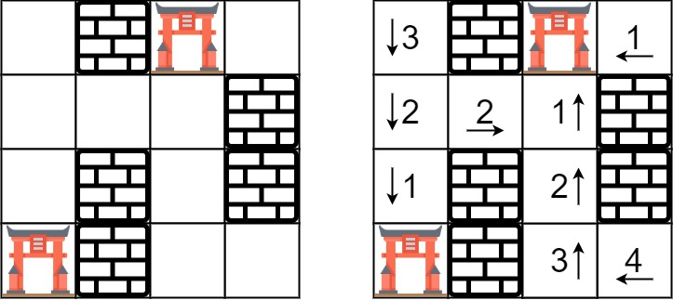

Input: rooms = [[2147483647,-1,0,2147483647],[2147483647,2147483647,2147483647,-1],[2147483647,-1,2147483647,-1],[0,-1,2147483647,2147483647]]  
Output: [[3,-1,0,1],[2,2,1,-1],[1,-1,2,-1],[0,-1,3,4]]

**Example 2:**

Input: rooms = [[-1]]  
Output: [[-1]]

**Constraints:**

* m == rooms.length
* n == rooms[i].length
* 1 <= m, n <= 250
* rooms[i][j] is -1, 0, or 231 - 1.